INDUSTRIAL TRAINING REPORT
ON
CYBER SECURITY &
AMAZON WEB SERVICE (AWS)
AT
SV GLOBAL SERVICES INDIA PRIVATE LIMITED
SUBMITTED IN PARTIAL FULFILLMENT OF THE REQUIREMENT FOR THE AWARD OF DIPLOMA
IN
COMPUTER SCIENCE ENGINEERING
By

KATAKAM ARVIND | (22054-CCB-006)
GAJULA RAKESH | (22054-CCB-015)
ANCHA SAHITHI | (22054-CCB-029)
VINAY KUMAR VANGALA | (22054-CCB-031)
SHIVA SAI CHALLA | (22054-CCB-050)

Under the Guidance Of
K. RADHIKA
Head of the department, CSE Dept.


GOVERNMENT INSTITUTE OF ELECTRONICS
(Approved by AICTE, Affiliated to SBTET, Hyderabad)
East Marredpally, Secunderabad, Hyderabad Dist. -500026, Telangana State, India.

DEPARTMENT OF
COMPUTER SCIENCE AND ENGINEERING

CERTIFICATE
This is to certify that the project entitled “INDUSTRIAL TRAINING REPORT”
has been carried out by

KATAKAM ARVIND | (22054-CCB-006)
GAJULA RAKESH | (22054-CCB-015)
ANCHA SAHITHI | (22054-CCB-029)
VINAY KUMAR VANGALA | (22054-CCB-031)
CHALLA SHIVA SAI | (22054-CCB-050)

In partial fulfilment for the award of DIPLOMA IN COMPUTER SCIENCE ENGINEERING to the STATE BOARD OF TECHNICAL EDUCATION AND TRAINING, Hyderabad at 2nd SHIT GOVERNMENT INSTITUTE OF ELECTRONICS, Hyderabad during the Academic year 2024

HEAD OF THE DEPARTMENT PROJECT GUIDE
Mrs. K. RADHIKA Mrs. V. KALPANA
Dept. of Computer Science Dept. of Computer Science and
Engineering Engineering
GOVERNMENT INSTITUTE OF GOVERNMENT INSTITUTE OF
ELECTRONICS ELECTRONICS
Hyderabad Hyderabad

INTERNAL EXAMINAR EXTERNAL EXAMINAR

ACKNOWLEDGEMENT

My Sincere Thanks to MR. DONIKENA RAJESH [B.tech, M.Tech, MBA, PGDBM], Director of SV GLOBAL SERVICES INDIA PVT LTD, for his guidance and support in all the areas of Work Environment.

My sincere thanks to MRS. K. RADHIKA, Head of the Department, Computer Science Engineering, Government Institute of Electronics & all the faculty of the Department for the encouragement and guidance provided.

I would like to express our thankfulness to MRS. KALPANA, for her constant motivation and valuable help through the report writing.

I am also thankful and fortunate enough to get constant encouragement, support and guidance from all the lecturers MR. T. NITESH, who helped us to
successfully complete out Industrial Training

KATAKAM ARVIND | (22054-CCB-006)
GAJULA RAKESH | (22054-CCB-015)
ANCHA SAHITHI | (22054-CCB-029)
VINAY KUMAR VANGALA | (22054-CCB-031)
CHALLA SHIVA SAI | (22054-CCB-050)

DECLARATION

We the Undersigned declare that the Project Report entitled “INDUSTRIAL TRAINING REPORT” written and submitted by us in an original work done under the guidance of Mr. T. NITESH. The matter here in is not reproduced from any other source.

KATAKAM ARVIND | (22054-CCB-010)
GAJULA RAKESH | (22054-CCB-030)
ANCHA SAHITHI | (22054-CCB-035)
VINAY KUMAR VANGALA | (22054-CCB-036)
CHALLA SHIVA SAI | (22054-CCB-050)

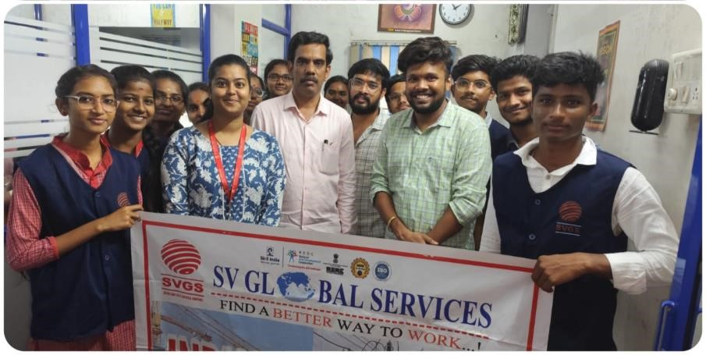
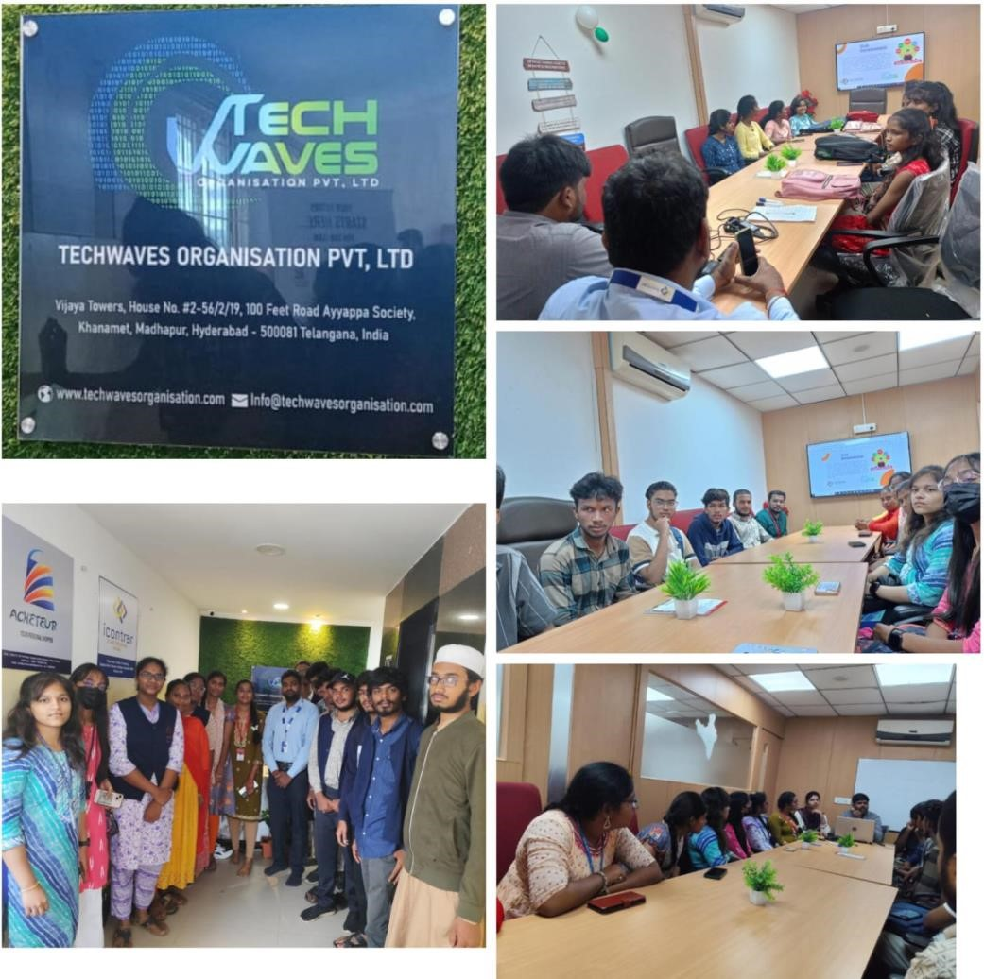
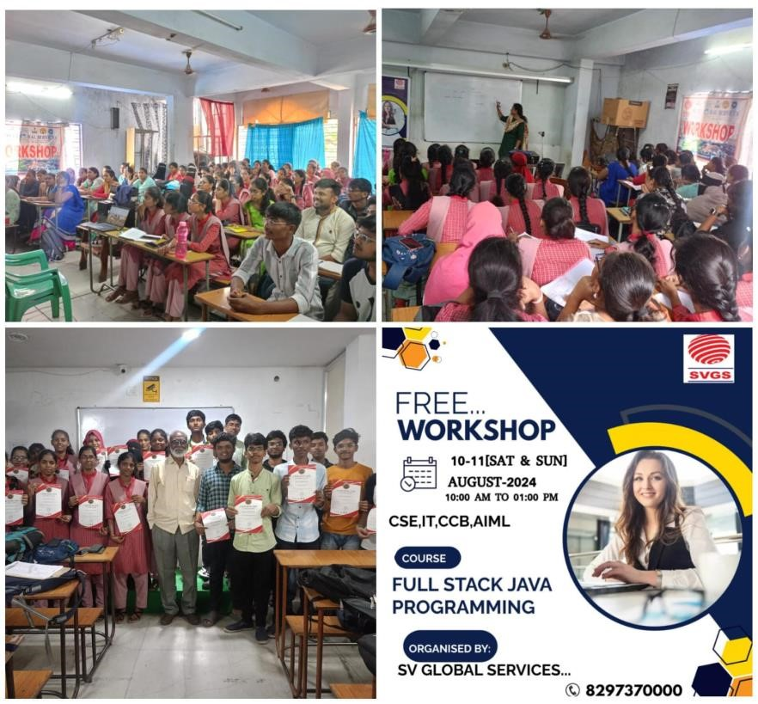

CONTENTS

- INTRODUCTION

  - INTRODUCTION ABOUT INDUSTRIAL TRAINING
  - INTRODUCTION ABOUT COMPANY

- CYBER SECURITY

  - CIA TRIAD
  - IAM
  - COMPLIANCE AND INTELLECTUAL PROPERTY
  - CRYPTOGRAPHY
  - OSI AND TCP/IP
  - DNS
  - NAT
  - PAT
  - FIREWALLS

- AWS (AMAZON WEB SERVICE)

  - AWS (AMAZON WEB SERVICE)
  - INTRODUCTION TO AWS
  - LINUX COMMANDS
  - YUM SOFTWARE
  - LINUX FLAVOURS
  - WEB HOSTING
  - INTODUCTION TO IAM
  - POLICIES
  - MFA
  - R-53
  - VPC
- DEVOPS

  - INTRODUCTION TO DEVOPS
  - GIT AND GITHUB
  - JENKINS
  - DOCKER
  - SDLC
  - WATERFALL MODEL
  - AGILE METHODOLOGY
  - SCRUM
  - KANBAN
  - SCRUMBAN

5. PROJECT
- OVERVIEW
- COMPONENTS
- ARCHITECHTURE
- CORE FUNTIONALITIES
- PROJECT SETUP AND EXECUTION
- ANCILLARY CONSIDERATIONS
- SUMMARY

CHAPTER 1:
INTRODUCTION

INTRODUCTION TO INDUSTRIAL TRAINING:

In today’s world, merely having a degree is no guarantee of employment, nor is it a reliable indicator of the individual’s competence in a job. Rather, graduates must have current and relevant knowledge, practical experience, soft skills and a positive attitude to allow them to be competitive in the job market. They must possess the necessary knowledge and skills before they go out into the working world. In line with this, the Industrial Training component of the undergraduate program constitutes a vital component in the drive to strengthen the key competencies required to improve the graduates’ ability to work.
Industrial Training refers to a program which aims to provide supervised practical training within a specified timeframe. This training can be carried out either in government organizations or in the private sector.
The main aim of the Industrial Training program is to produce graduates who are ready to face the working world. The program also aims to produce the knowledgeable, skilled and experienced graduates, demanded by employers, who are able to apply the knowledge acquired at university to the working world. The Industrial Training program provides opportunities for exposure to the working World, which will make graduates more aware of the hopes and expectations that industry has of them. The program will also equip students with real work experience. Placing students in industry also increases their chances of employment after graduation, as there is a strong possibility that they will be offered a job in the same place where they do their training. Apart from this, the training experience will further solidify the on-campus learning process and activities, while also providing students with relevant work experience.

Introduction about company

SV GLOBAL SERVICES OPC PVT LTD


ABOUT US
SV GLOBAL SERVICES- SVGS is Incorporated in 2016 is known for its integrated curriculum with equal importance to academics, employable skills.
SVGS Institute of Technology is located at Hyderabad, Telangana & Vizg, Andhra Pradesh, India. The institution was started in 2016 by the BMS Education Services, headed by Mr. Donikena Rajesh. The Institute has Six UG courses Training along with Seven PG Courses Training. The Institute is affiliated by AICTE.
SVGS conducting training programs for various software fields & provides certificate for both individuals and organizations. We have built a strong reputation to provide an excellent service to individuals with a team of fully qualified professionals.SV GLOBAL SERVICES designs and develops state of-the-art combat training solutions for the training. We’re serving to All Technical Students with Quality Education.
(ISO-9001:2015) company IEEE Certified
in Robotics

Our Vision
Promote Academic Excellence, Research, Innovation and Entrepreneurial Skills to Produce Graduates with Human Values and Leadership Qualities to Serve the Nation.
Our mission
To Enrich the knowledge of graduate engineers for global requirements by promoting quality education though innovative pedagogical practices

Code of conduct

Confidentiality:

We give great preference to confidentiality. Any information shared with us during any assignment remains confidential and is not disclosed to any third party. We ensure that both the parties are immediately informed of any conflict of interests or the slightest possibility of the same between clients.

Communication:
We maintain transparency in our communication both with client and candidates. Information to client is provided clearly if we find a particular assignment is within our capabilities/focus or not. Agreement is made about the professional fees for the executive search with the client prior to the commencement of the project.

Quality:
Quality plays a crucial role in the services we provide. We never encourage unsolicited profiles nor send them to client from our end. From the date of joining, for one year we provide any openings to the candidate provided if the client requests us for outplacement of the candidate always, we represent our client during salary negotiations, but being fair with the candidate at the same time

CHAPTER 2:
CYBER SECURITY

2.1 CIA Triad- (Confidentiality Integrity Availability)

Used in every single domain of CS.

C - Data is hidden and only visible to authorized users. Drive ex and also enforced through encryption. Violations: packet sniffing, breaking encryption, human error.

I - Your data is accurate it has not been modified. Enforced through hashes, violations: modification of data during transit hashes are a kind of summary or a message digest of your original data so that if anything changes in your data so that hash will also change so at the destination the receiver can simply check the hash to make sure the data has not been modified.
A - Data is available as & when required violations happen if someone damages your communication
Passwords attempt ex
Email ex with other people Data inserted in our documents

2.2 IAM: (Identity Access Management)

Divided into 2 parts
IAAA – Identity Authentication (passwords, pin, biometric or MFA) Authorization (access control lists, level of clearances)
Accountability (log views, audit mechanisms)
Identity life cycle:
Provisioning:
1) Creating new accounts.
2) Assigning privileges.
Review: periodic account review, disable in active accounts, audit privilege creep.

Revocation:
Disable accounts of employee who leave, retire or terminated. (Revocation is more important in CS if an employee is terminated or left from org, he can’t able to accesses the company account so that he may leverage those accesses to launch attacks on the company).

Authentication Factors:
Many this discusses from weakest to strongest.
Type 1: something you know (password, pin)
Type2: something you have (smart card, sim)
Type 3: something that you are (retina, iris scan, fingerprints, voice patterns, palm scans).
These all has single factor authentication.
And combination of any of this three is called as MFA. (2FA,
3FA)

Authorization:
Decides who is allowed to perform what.
User only view his account.
Admin can create & delete user accounts.
Accountability – logging user activates for accountability.
Audits of logs & accounts to identity any violations.
Authorization: privilege creep (someone get promoted to manager his account accesses)
There is no. of sources of information which can help with the accountability process for ex:
- Network logs (routers, switches, firewall)
- DB logs (data information, files accessed)
- Application logs (exceptions, crashes)
- System logs (resources used, applications executed).
- Identity Federation (IF)
Ex: while sign in to some new app. There is an option using email or mobile or google or login if an old user that is an IF
Gmail is used for login for multiple app
It provides the framework under which two different entities can establish trust relationships.
Login ex with Hotstar VIP account.
Protocols of if: SAML (security assertion markup language), OAuth, OIDC (open ID Connect).

Security Governance:
Security governance is of 3 layers they are:

Policies: defines responsibilities for management and users, defined for long terms, organization wide

Standards: rule to achieve the intent of the policy

Procedures &guidelines: specific steps, train employees & ensure consistency in security related business process.

2.3 Compliance & intellectual property.
Before starting this, we need to know some key elements like:
1. PII (personally identifiable information): used to identify, contact or locate someone
Ex: for bank new account they ask for name mobile number, Aadhar for address
2. PHI (protected health information): includes information including health plans, payment history. (ex: loan process they will buy insurance for you)

Some regulatory compliances are:
1. GDPR: (general data protection regulation).

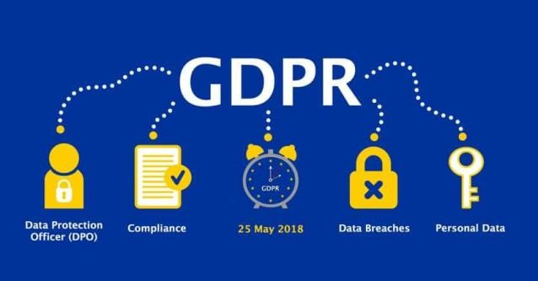

2. HIPAA: (Health insurance portability & accountability).



3. PCI-DSS: (payment card industry data security standard protection regulation).
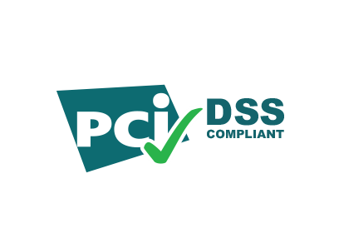

We can use self-payment but your site should be https, or we can use 3rd party app like razor pay, PayPal.

2.4 Cryptography:

The study & methods, techniques to protect information by using codes for security communication.
3 categories:
1) Symmetric encryption:
Also called as private key encryption.
Same key& algorithm (Cipher) used for encryption & decryption (so symmetric)
Key length determines the strength of encryption (longer key is better)
Popular private key ciphers: AES, Rc5, two Fish.

2) Asymmetric cryptography:
Different key for encryption. Public key used for encryption private key for decryption. Private Key is completely diff from public key. Data encrypted by public key cannot be decoded by public key.
It must be done only by private key. If sender is using his private key to encrypt then it is not for secrecy but for digital signing a document. The magic is in special mathematic operations.
Popular asymmetric solutions:
Diffle Hellman: used for key exchange.
RSA, ECC: used for actual encryption/decryption.

Hashing & Digital Signatures:
You provide a document or an input to a one-way hashing function, which basically generates a fixed sized message digest or a summary as the o/p. hashing functions are one-way function. Message digest it is impossible for you to reverse the hash function & obtain the original document.
If you generate 2 different hashes which means that different inputs should lead to different outputs.
Digital signature’s:
It is that if someone digitally signed a document or a data, then they are giving assurance like this data or this file is in fact coming from them.
It always done using the private key. A single public key is required to distribute to thousands of users.
Confidentiality can additionally be offered by encrypting the entire file using private key in addition to the hash.
Some popular hashing tools are:
- Message digest algorithm: It creates 128-bit o/p hashes, has been shown to suffer from collisions.
- SHA-2 (Secure Hash Algorithm).

2.5 OSI & TCP/IP: Application layer: (WWW)

Primary protocol which runs at the application layer is the HTTP protocol which is used to accesses www Web page is made up of objects (tags &fields etc...) of html pages. It uses the reliable TCP protocol on transport layer.

2.6 DNS (Domain Name system):
Ex: google.com
Internet understand 8.8.8.8 (IP or 12.13.11.12)
We cannot have one DNS server. We must have multiple DNS servers distributed load globally.
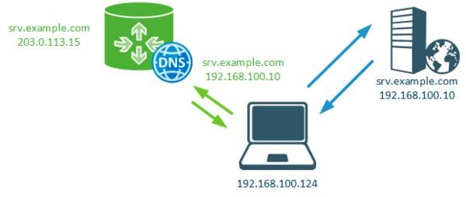

Port Scanning:
An important tool in pen tester Armor & identities:
Open ports
FTP-21, SSH-22, Telnet -23, SMTP- 25, DNS-53, HTTP-80, HTTPS-443, SQL -1433.
Types of port scans:
- TCP/UDP Port scans. (used for small applications)
- Stealth scans (used for not normal tools)

2.7 NAT (Network Address Translation):
Used on network gateway &offers:
- A single public IP address to handle thousands of systems
- Use of private IP address
- Hiding the IP addresses of internal system.
- Prevent connection initiation from outside.

2.8 PAT (port address translation):
- Nat is used for one-to-one mapping of private IP to public IP, so essentially, we have PAT to avoid that.
- NAT/PAT provide some point of security.

2.9 Firewalls:

First line of defense against attacks like spoofing mails or hackers trying to enter our application.
So, design a good firewall for higher security of website.

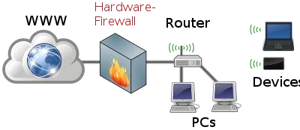

CHAPTER 3:
AWS (Amazon Web Services)

3.1 Introduction to AWS:

In 2006, Amazon Web Services (AWS) began offering IT infrastructure services to businesses as web services—now commonly known as cloud computing. One of the key benefits of cloud computing is the opportunity to replace upfront capital infrastructure expenses with low variable costs that scale with your business. With the cloud, businesses no longer need to plan for and procure servers and other IT infrastructure weeks or months in advance. Instead, they can instantly spin up hundreds or thousands of servers in minutes and deliver results faster.
What are the services provided by AWS?

- Each type of service in this “What is AWS” blog, is categorized under a domain, the few domains which are widely used are:
- Compute Storage
- Database
- Migration.
- Network and Content Delivery Management Tools
- Security & Identity Compliance Messaging

Steps to create an AWS account: -
- Open the Amazon Web Services home page.
- Choose Create an AWS account.
Note:

If you signed in to AWS recently, that option might not be there. Instead, choose Sign in to the Console. Then, if create a new AWS account still isn't visible, first choose Sign in to a different account, and then choose Create a new AWS account.
Enter your account information, and then choose Verify email address. This will send a verification code to your specified email address.
Important:

Because of the critical nature of the AWS account root user of the account, we strongly recommend that you use an email address that can be accessed by a group, rather than only an individual. That way, if the person who signed up for the AWS account leaves the company, the AWS account can still be used because the email address is still accessible.
If you lose access to the email address associated with the AWS account, then you can't recover access to the account if you ever lose the password.
Enter your verification code, and then choose Verify.
Enter a strong password for your root user, confirm it, and then choose Continue. AWS requires that your password meet the following conditions:

- It must have a minimum of 8 characters and a maximum of 128 characters.
- It must include a minimum of three of the following mix of character types: uppercase, lowercase, numbers, and, ‘! @ # $ % ^ & * () <> [] {} | _+-=’ symbols.
- It must not be identical to your AWS account name or email address.
- Choose Business or Personal. Personal accounts and business accounts have the same features and functions.
- Enter your company or personal information.
Important:

For business AWS accounts, it's a best practice to enter:
- A company phone number rather than a number for a personal phone.
- An e-mail address with a domain name that belongs to the company or organization that will be using the account.
- Configuring the account's Using the AWS account root user with an individual email address or a personal phone number can make your account insecure.
Read and accept the AWS Customer Agreement. Be sure that you read and understand the terms of the AWS Customer Agreement.
- Choose Continue. At this point, you'll receive an email message to confirm that your AWS account is ready to use. You can sign in to your new account by using the email address and password you provided during sign up. However, you can't use any AWS services until you finish activating your account.
- Enter the information about your payment method, and then choose Verify and Continue. If you want to use a different billing address for your AWS billing information, choose Use a new address.
- You can't proceed with the sign-up process until you add a valid payment method.
- Enter your country or region code from the list, and then enter a phone number where you can be reached in the next few minutes.
- Enter the code displayed in the CAPTCHA, and then submit.
- When the automated system contacts you, enter the PIN you receive and then submit.
- Select one of the available AWS Support plans. For a description of the available Support plans and their benefits, see Compare AWS Support plans.
- Choose complete sign up. A confirmation page appears that indicates that your account is being activated.
- Check your email and spam folder for an email message that confirms your account was activated. Activation usually takes a few minutes but can sometimes take up to 24 hours.
- After you receive the activation message, you have full access to all AWS services.

3.2 Linux commands in AWS:
- ls – shows the list of files.
- Cd filename – to open or move the folders.
- mkdir filename - to create a folder.
- touch filename - to create a file.
- vi filename - to create a file & open a file.
- I - used for inserting.
- Save file - press escape colon (:) WQ.
- cat filename - to know the content.
- Nano - it is a command used to open the file.
- LATR - shows the hidden files.
- LL - shows the list of files briefly.
- Pwd – Pwd (present working directory) shows the path of current working directory.
- Touch filename - used to create the no. of files in same folder.
- RM filename - delete the file.
- MV old file to new file - to remove the file.
- CP one file to another file - To copy the content in one file to another file.
- Cat filename - enter
- Cd - goes to previous folder.
- Cd ~ - which directly goes to home
- YUM - play store in AWS.
- YUM update – to update.
- YUM install git – to install the git.
- Service app name start – to start a service.
- History - to know the history.
- Clear - will clear the screen.
- Bash - used to refresh.

3.3 Yum software:

Yum is a software package management utility used in many popular Linux distributions, including fedora and centos. Yum is a front-end for the RPM package manager, meaning that it manages packages in the .rpm file format.
“Yum” is an acronym that stands for yellowdog updates modified. A package is usually a software application but the term can also encompass other items such as documentation, source code, and extra levels for games. Packages management is a term used to describe the processes of adding, removing, and updating software on a computer.

3.4 Linux flavors’:
 Amazon Linux
 CentOS
 Debian
 Kali
 Red Hat
 SUSA
 Ubuntu

3.5 Web hosting:

A web hosting service is a type of internet hosting service that hosts websites for clients i.e. it offers the facilities required for them to create and maintain a site and makes it accessible on the World Wide Web (www). Companies providing web hosting services are sometimes called web hosts.
Start hosting a web site in 5 steps:
 Educate yourself
 Choose a provider
 Pick your plan
 Enter your domain
 Choose your package

3.6 Introduction to IAM:

AWS Identity and Access Management (IAM) is a web service that helps to securely control access to AWS resources. With IAM, we can centrally manage permissions that control which AWS resources users can access. It creates for individuals within an AWS account to have controlled access. Assigned specific permissions and policies. It provides principle of teats privilege. It follows the principle of granting least privileges.

3.7 Policies:

A policy is an object in AWS that, when associated with an entity or resource, defines their permissions. AWS evaluates these policies when a principal, such as a user, makes a request. Permissions in the policies determine whether the request is allowed or denied. Most policies are stored in AWS as JSON documents.

3.8 MFA:

AWS multi-factor authentication (MFA) is an AWS Identity and Access Management (IAM) best practice that requires a second authentication factor in addition to user name and password sign-in credentials. You can enable MFA at the AWS account level for root and IAM users you have created in your account.

3.9 CIDR blocks:

Classless inter domain routing (CIDR) is an IP address allocation method that improves data routing efficiency on the internet. Every machine, server, and end-user device that connects to the internet has a unique number, called an IP address, associated with it. Devices find and communicate with one another by using these IP address. Organizations use CIDR to allocate IP addresses flexibly and efficiently in their networks.


3.10 R-53:

Amazon Route 53, part of the Amazon Web Services (AWS) cloud computing platform from Amazon.com normally referred to as AWS Route 53, is a highly available, scalable Domain Name System (DNS) service. The AWS Route 53 DNS service connects user requests to ELB load balancers, Amazon EC2 instances, Amazon S3 buckets, and other infrastructure running on AWS.

3.11 VPC:

- VPC stands for Virtual Private Cloud.
- Amazon Virtual Private Cloud (Amazon VPC) provides a logically isolated area of the AWS cloud where you can launch AWS resources in a virtual network that you define.
- It can complete control over the virtual networking environment, including a selection of the IP address range, the creation of subnets, and configuration of route tables and network gateways.
- It can easily customize the network configuration of the Amazon
- Virtual Private Cloud. For example, you can create a public-facing
- Subnet for web servers that can access to the internet and can also place your backend system such as databases or application servers to a private-facing subnet.
- It can provide multiple layers of security, including security groups and network access control lists, to help control access to Amazon EC2 instances in each subnet.
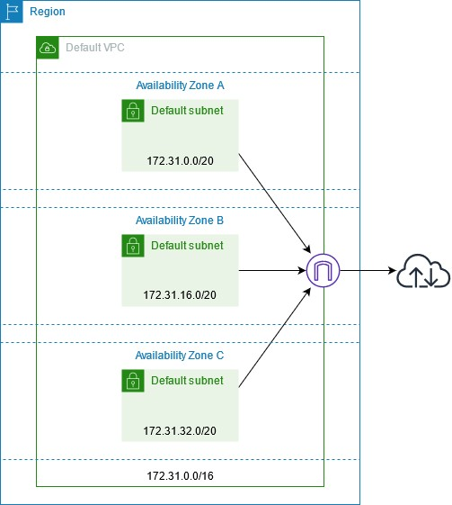

CHAPTER 4:
DevOps

4.1 Introduction to DevOps:

DevOps is an amalgamation of "development" and "operations", represents a transformative approach to software development and IT operations. It emphasizes collaboration, communication, and integration between traditionally soloed teams, aiming to streamline the software delivery process and improve overall organizational performance.
In today's fast-paced digital landscape. DevOps has emerged as a cornerstone of modern software development practices, empowering teams to innovate faster, respond to market changes more effectively, and drive business success.

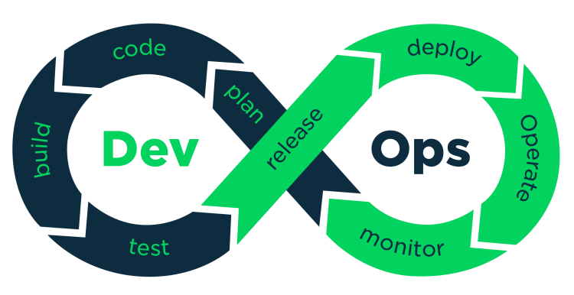
DevOps goes beyond continuous integration and continuous delivery to enable near-instantaneous deployment of products and services in the cloud.
DevOps can be best explained as people working together to conceive, build and deliver secure software at top speed.

CI-CD Pipeline:
A continuous integration and continuous deployment (CI/CD) pipeline is a series of steps that must be performed in order to deliver a new version of software. CI/CD pipelines are a practice focused on improving software delivery throughout the software development life cycle via automation.

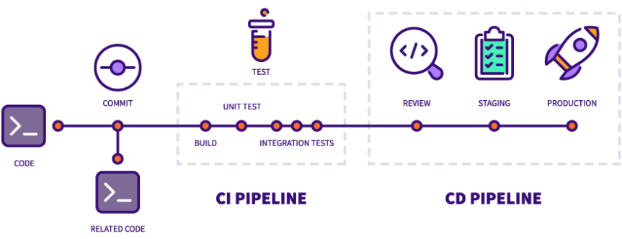
By automating CI/CD throughout development, testing, production, and monitoring phases of the software development lifecycle, organizations are able to develop higher quality code, faster and more securely. Although it’s possible to manually execute each of the steps of a CI/CD pipeline, the true value of CI/CD pipelines is realized through automation.

CI (Continuous Integration):
Continuous integration is the practice of integrating all your code changes into the main branch of a shared source code repository early and often, automatically testing each change when you commit or merge them, and automatically kicking off a build. With continuous integration, errors and security issues can be identified and fixed more easily, and much earlier in the development process.
By merging changes frequently and triggering automatic testing and validation processes, you minimize the possibility of code conflict, even with multiple developers working on the same application. A secondary advantage is that you don't have to wait long for answers and can, if necessary, fix bugs and security issues while the topic is still fresh in your mind.
Common code validation processes start with a static code analysis that verifies the quality of the code. Once the code passes the static tests, automated CI routines package and compile the code for further automated testing. CI processes should have a version control system that tracks changes so you know the version of the code used.
CD (Continuous Delivery):
Continuous delivery is a software development practice that works in conjunction with CI to automate the infrastructure provisioning and application release process.
Once code has been tested and built as part of the CI process, CD takes over during the final stages to ensure it's packaged with everything it needs to deploy to any environment at any time. CD can cover everything from provisioning the infrastructure to deploying the application to the testing or production environment.
With CD, the software is built so that it can be deployed to production at any time. Then you can trigger the deployments manually or move to continuous deployment, where deployments are automated as well.

4.2 GIT and GitHub:

Git is the most popular distributed version control system. Git is commonly used for both open source and commercial software development, with significant benefits for individuals, teams and businesses.
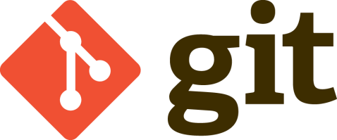
Git lets developers see the entire timeline of their changes, decisions, and progression of any project in one place. From the moment they access the history of a project, the developer has all the context they need to understand it and start contributing.
Developers work in every time zone. With a DVCS like Git, collaboration can happen any time while maintaining source code integrity. Using branches, developers can safely propose changes to production code.
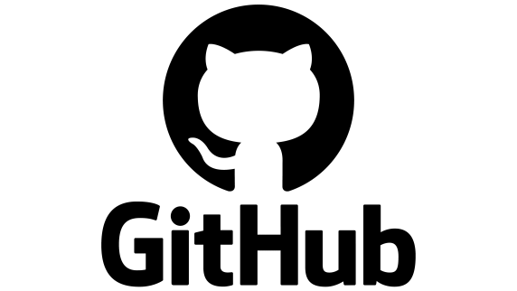
GitHub hosts Git repositories and provides developers with tools to ship better code through command line features, issues (threaded discussions), pull requests, code review, or the use of a collection of free and for purchase apps in the GitHub Marketplace. With collaboration layers like the GitHub flow, a community of 100 million developers, and an ecosystem with hundreds of integrations, GitHub changes the way software is built.
GitHub builds collaboration directly into the development process. Work is organized into repositories where developers can outline requirements or direction and set expectations for team members. Then, using the GitHub flow, developers simply create a branch to work on updates, commit changes to save them, open a pull request to propose and discuss changes, and merge pull requests once everyone is on the same page. For more information, see "GitHub flow."

4.3 Jenkins:

Jenkins is an open-source continuous integration/continuous delivery and deployment (CI/CD) automation software DevOps tool written in the Java programming language. It is used to implement CI/CD workflows, called pipelines.
Pipelines automate testing and reporting on isolated changes in a larger code base in real time and facilitates the integration of disparate branches of the code into a main branch. They also rapidly detect defects in a code base, build the software, automate testing of their builds, prepare the code base for deployment (delivery), and ultimately deploy code to
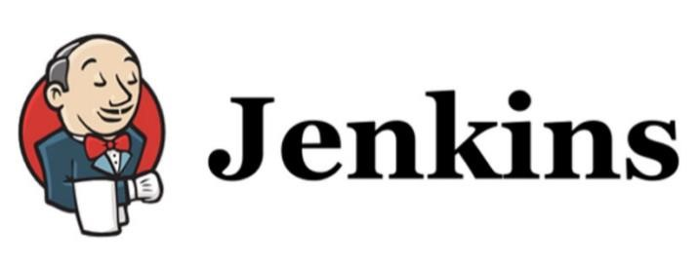
Containers and virtual machines, as well as bare metal and cloud servers. There are several commercial versions of Jenkins. This definition only describes the upstream Open-Source project.

4.4 Docker:

Docker is an open platform for developing, shipping, and running applications. Docker enables you to separate your applications from your infrastructure so you can deliver software quickly. With Docker, you can manage your infrastructure in the same ways you manage your applications. By taking advantage of Docker's methodologies for shipping, testing, and deploying code, you can significantly reduce the delay between writing code and running it in production.
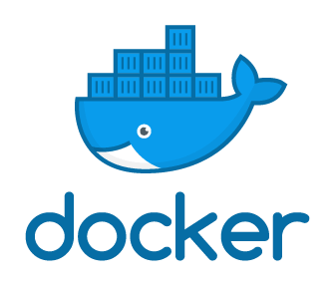

Docker streamlines the development lifecycle by allowing developers to work in standardized environments using local containers which provide your applications and services. Containers are great for continuous integration and continuous delivery (CI/CD) workflows.
Docker containers that run on Docker Engine:
Standard: Docker created the industry standard for containers, so they could be portable anywhere

Lightweight: Containers share the machine’s OS system kernel and therefore do not require an OS per application, driving higher server efficiencies and reducing server and licensing costs

Secure: Applications are safer in containers and Docker provides the strongest default isolation capabilities in the industry

4.5 SDLC (Software Development Life Cycle):

Software development life cycle (SDLC) is a structured process that is used to design, develop, and test good-quality software. SDLC, or software development life cycle, is a methodology that defines the entire procedure of software development step-by-step.

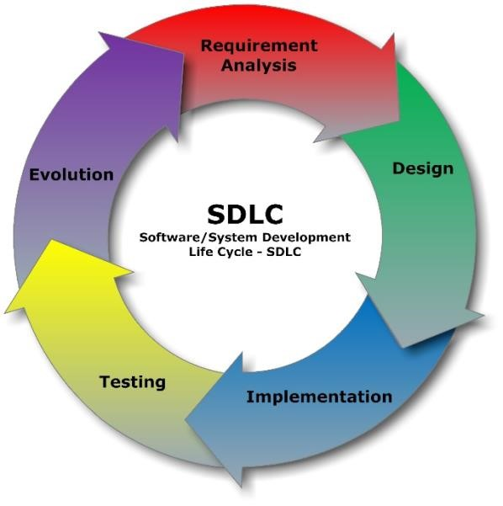

The goal of the SDLC life cycle model is to deliver high-quality, maintainable software that meets the user’s requirements. SDLC in software engineering models outlines the plan for each stage so that each stage of the software development model can perform its task efficiently to deliver the software at a low cost within a given time frame that meets users’ requirements

SDLC specifies the task(s) to be performed at various stages by a software engineer or developer. It ensures that the end product is able to meet the customer’s expectations and fits within the overall budget. Hence, it’s vital for a software developer to have prior knowledge of this software development process. SDLC is a collection of these six stages, and the stages of SDLC are as follows:
Planning:

The planning phase typically includes tasks like cost benefit analysis, scheduling, resource estimation, and allocation. The development team collects requirements from several stakeholders such as customers, internal and external experts, and managers to create a software requirement specification document.
The document sets expectations and defines common goals that aid in project planning. The team estimates costs, creates a schedule, and has a detailed plan to achieve their goals.
Designing:

In the design phase, software engineers analyze requirements and identify the best solutions to create the software. For example, they may consider integrating pre-existing modules, make technology choices, and identify development tools. They will look at how to best integrate the new software into any existing IT infrastructure the organization may have.
Development:

In the development phase, the development team codes the product. They analyze the requirements to identify smaller coding tasks they can do daily to achieve the final result.

Testing:

The development team combines automation and manual testing to check the software for bugs. Quality analysis includes testing the software for errors and checking if it meets customer requirements. Because many teams immediately test the code they write, the testing phase often runs parallel to the development phase.

Pre-production (UAT):

When teams develop software, they code and test on a different copy of the software than the one that the users have access to. The software that customers use is called production, while other copies are said to be in the build environment, or testing environment.
Having separate build and production environments ensures that customers can continue to use the software even while it is being changed or upgraded. The deployment phase includes several tasks to move the latest build copy to the production environment, such as packaging, environment configuration, and installation.

Production:

In the production phase, among other tasks, the team fixes bugs, resolves customer issues, and manages software changes. In addition, the team monitors overall system performance, security, and user experience to identify new ways to improve the existing software.

4.6 Waterfall model:

The Waterfall Model is a linear application development model that uses rigid phases: When one phase ends, the next begins. Steps occur in sequence, and, if unmodified, the model does not allow developers to go back to previous steps.
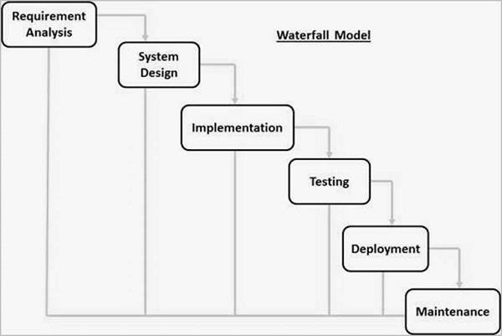

The Waterfall model is the earliest SDLC approach that was used for software development. The waterfall Model illustrates the software development process in a linear sequential flow. This means that any phase in the development process begins only if the previous phase is complete. In this waterfall model, the phases do not overlap.
Drawbacks of Waterfall model:

- However, the waterfall model has drawbacks, including its inflexibility and lack of revision
- Opportunities. Some specific concerns include the following:
- Design flaws, when discovered, often mean starting over from scratch
- It doesn’t incorporate mid-process feedback from users or clients and makes changes based on results
- Delaying the testing until the end of development is common
- There’s no consideration for error correction
- The model doesn’t accommodate changes, scope adjustments, and updates well
- Work on different phases doesn’t overlap, which reduces the efficiency
- Projects don’t produce a working product until later stages
- Not an ideal model to use for complex and high-risk projects

4.7 Agile Methodology:

Agile methodology is a project management framework that breaks projects down into several dynamic phases, commonly known as sprints.
The Agile framework is an iterative methodology. After every sprint, teams reflect and look back to see if there was anything that could be improved so they can adjust their strategy for the next sprint.
There's a reason why they call it the agile methodology. One of the main benefits of using agile processes in software development is the ability to shift strategies quickly, without disrupting the flow of a project.
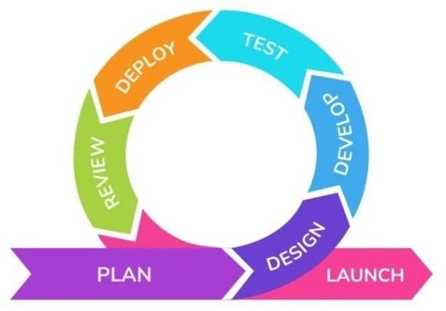
Because phases in the traditional waterfall method flow into one another, shifting strategies is challenging and can disrupt the rest of the project roadmap. Since software development is a much more adaptable field, project managing rapid changes in the traditional sense can be challenging. This is part of the reason why agile project management is favored in software development.

The 12 agile principles:
The four values of Agile are the pillars of agile methodology. From those values, the team developed 12 principles.
If the four values of Agile are the weight-bearing pillars of a house, then these 12 principles are the rooms you can build within that house. These principles can be easily adapted to fit the needs of your team. The 12 principles used in Agile methodology are:
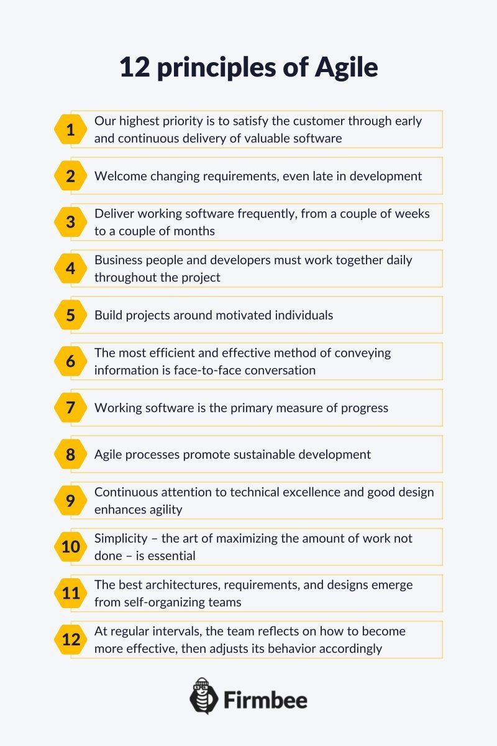

4.8 Scrum:

Scrum is a management framework that teams use to self-organize and work towards a common goal. It describes a set of meetings, tools, and roles for efficient project delivery. Much like a sports team practicing for a big match, Scrum practices allow teams to self-manage, learn from experience, and adapt to change. Software teams use Scrum to solve complex problems cost effectively and sustainably.

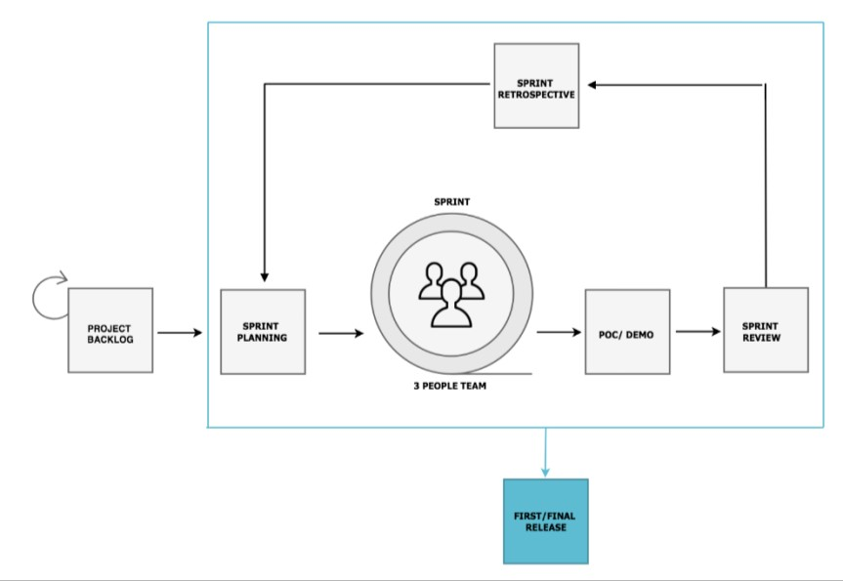

Scrum Events:
Scrum events or Scrum ceremonies are a set of sequential meetings that Scrum Teams perform regularly. Some Scrum events include the following:
Sprint Planning
In this event, the team estimates the work to be completed in the next Sprint. members define Sprint Goals that are specific, measurable, and attainable. At the end of the planning meeting, every Scrum member knows how each Increment can be delivered in the Sprint.
Sprint
A Sprint is the actual time period when the Scrum Team works together to finish an Increment. Two weeks is the typical length for a Sprint but can vary depending on the needs of the project and the team. The more complex the work and the more unknowns, the shorter the Sprint should be.
Daily Scrum or stand-up
A Daily Scrum is a short meeting in which team members check in and plan for the day. They report on work completed and voice any challenges in meeting Sprint Goals. It is called a stand-up because it aims to keep the meeting as short as practical—like when everybody is standing.
Sprint Review
At the end of the Sprint, the team gets together for an informal session to review the work completed and showcase it to stakeholders. The Product Owner might also rework the Product Backlog based on the current Sprint.
Sprint Retrospective
The team comes together to document and discuss what worked and what didn’t work during the Sprint. Ideas generated are used to improve future Sprints.

What is a Scrum master?
A Scrum master is a facilitator for an Agile development team. They are responsible for managing the exchange of information between team members. Scrum is a project management framework that enables a team to communicate and self-organize to make changes quickly, in accordance with Agile principles.
Although the scrum analogy was first applied to manufacturing in a paper by Hirotaka Takeuchi and Ikujiro Nonaka, the approach is often used in Agile software development and other types of Agile project management. The term comes from the sport rugby, where opposing teams huddle together during a scrum to restart the game.
In product development, team members huddle together each morning for a daily stand-up meeting where they review progress and essentially restart the project.

Roles, responsibilities of a Scrum master:

Although the title of Scrum master sounds powerful, this position is not the project leader and is not held accountable for project outcomes; this responsibility is given to the team as a whole. Although the official Scrum Guide no longer refers to the Scrum master as a servant leader as it once did, their purpose does serve the team through the Scrum process, creating a framework in which every team member can do their best work to meet a common goal.
An ideal Agile team has the team -- not one individual -- manage its process. However, the Scrum master position evolved to take responsibility, while keeping the process as team-oriented as possible.

4.9 Kanban:

A Kanban board is one of the tools that can be used to implement Kanban to manage work at a personal or organizational level.
Kanban boards visually depict work at various stages of a process using cards to represent work items and columns to represent each stage of the process. Cards are moved from left to right to show progress and to help coordinate teams performing the work. A Kanban board may be divided into horizontal "swim lanes" representing different kinds of work or different teams performing the work.
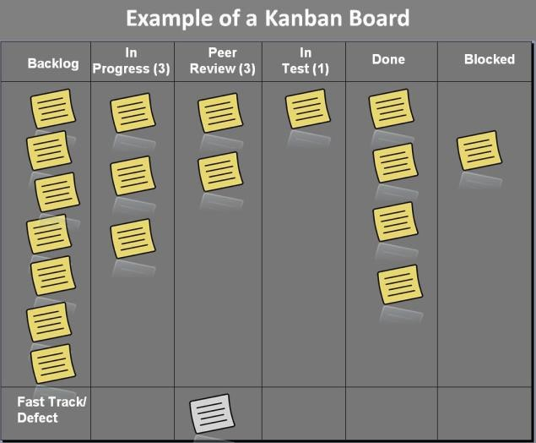
Kanban boards can be used for knowledge work or manufacturing processes.
Simple boards have columns for "waiting", "in progress", and "completed" or "to-do", "doing", and "done". Complex Kanban boards can be created that subdivide "in progress" work into multiple columns to visualize the flow of work across a whole value stream map.
According to the Project Management Institute, a Kanban board is a "visualization tool that shows work in progress to help identify bottlenecks and over commitments, thereby allowing the team to optimize the workflow."

4.10 Scrumban:

Scrumban is a project management methodology that combines two common Agile
Strategies: Scrum and Kanban. Scrumban was initially developed to help teams transition from Scrum to Kanban, or vice versa. If teams have experience with one strategy over another, this technique can help them gradually cross over to the other methodology.
While Scrumban was initially intended to help teams transition, some may find that this combination of the two strategies works the best for their team. Scrumban is best used by a team that already knows some facets of Scrum or Kanban. The experience they have will give them some familiarity when they start using the Scrumban methodology.
There’s no team hierarchy in Scrumban. This means that every person on the development team has the same opportunity as others to make decisions and choices. This also means that there is no clear leader for the group—rather, the team is entirely self-managed.

CHAPTER 5:
PROJECT

5.1 OVERVIEW

The Facial Attendance Integrated with AWS project is a modern solution that automates attendance marking using facial recognition technology while leveraging the cloud's power for secure and scalable data management. This system captures the faces of users, identifies them in real-time, and logs attendance automatically. By integrating with Amazon Web Services (AWS), the project securely stores attendance data in the cloud, ensuring accessibility, durability, and scalability of records.

The core advantage of this system is its efficiency and security. It eliminates the need for physical interactions, streamlining attendance processes in educational institutions, workplaces, or events. By using AWS services such as S3 (Simple Storage Service) for storing attendance logs and facial data, the system ensures data integrity and allows easy access from anywhere.

This project balances ease of use with advanced features such as PIN-based identification, real-time feedback via speech synthesis, and data protection through AWS cloud infrastructure. This solution offers an innovative and practical application of facial recognition and cloud technologies.

5.2 COMPONENTS

- Python-based Facial Recognition System
Utilizes OpenCV and face_recognition libraries to capture and recognize faces in real time. Each user is identified with a unique PIN during face registration, ensuring accurate attendance records.
- AWS S3 Storage
The attendance data is stored securely in AWS S3 as CSV files. The system uses AWS IAM roles for managing access to the S3 bucket, ensuring data integrity and secure cloud storage.
- Streamlit Web Interface
A simple and interactive web interface created with Streamlit that allows users to view attendance data. The interface also includes a search feature for finding specific records.
- CSV Data Management
Attendance records are logged in CSV format with details like the user’s name, PIN, time, and date, enabling easy data retrieval and analysis.
- Speech Feedback System
Provides real-time voice feedback using pyttsx3, confirming when a user’s attendance is successfully marked.
- User Registration Module
Users register their face along with a unique PIN during the setup, which is used to verify their identity during attendance marking.
- Control & Gesture Features
Attendance is triggered via specific keyboard input (e.g., pressing "p" to mark attendance, "e" to exit the camera frame), allowing for smooth, user-friendly interactions.

5.3 CORE FUNCTIONALITIES

- Face Recognition-Based Attendance
Using OpenCV and the face_recognition library in Python, the system captures and recognizes faces in real-time. Once a face is detected, the system verifies the individual by matching it with the stored data, allowing for secure, PIN-based attendance marking.
- PIN-Based User Verification
Each user is associated with a unique PIN number during the registration process. This PIN, entered during facial registration, is used for identity verification when marking attendance, adding an extra layer of security.
- Attendance Logging and Storage (CSV Format)
When attendance is successfully marked, the system records the user’s name, PIN, timestamp, and date into a CSV file. This file serves as the primary attendance record and is stored locally for instant access.
- AWS S3 Integration for Cloud Storage
The attendance records (CSV files) are automatically uploaded to an AWS S3 bucket for secure, cloud-based storage. This ensures long-term storage, central access, and backup of attendance data. AWS IAM roles and policies are applied to manage access securely.
- Streamlit Web Interface for Data Visualization
A web interface built using Streamlit allows administrators and users to view the attendance records interactively. The data is pulled from the AWS S3 bucket and displayed in a tabular format, with a search feature that enables users to filter attendance records by name or PIN.
- Real-Time Speech Feedback
Once a user’s attendance is marked, the system provides immediate voice feedback, announcing the user’s name and confirming that their attendance has been logged. This feature is implemented using pyttsx3.
- Control via Keyboard Inputs
The system offers intuitive keyboard-based control:
- Pressing "p" marks the attendance of a recognized user.
- Pressing "e" exits the camera frame, terminating the recognition session.
- Flexible and Scalable Design
The system is designed to be scalable, capable of handling multiple users, and extensible to include additional functionalities such as reporting or integration with other services.

5.4 STEP-BY-STEP IMPLEMENTATION

Step 1: Setting Up Your Development Environment
  - Install Python
Ensure you have Python 3.x installed on your system. You can download it from the official Python website.
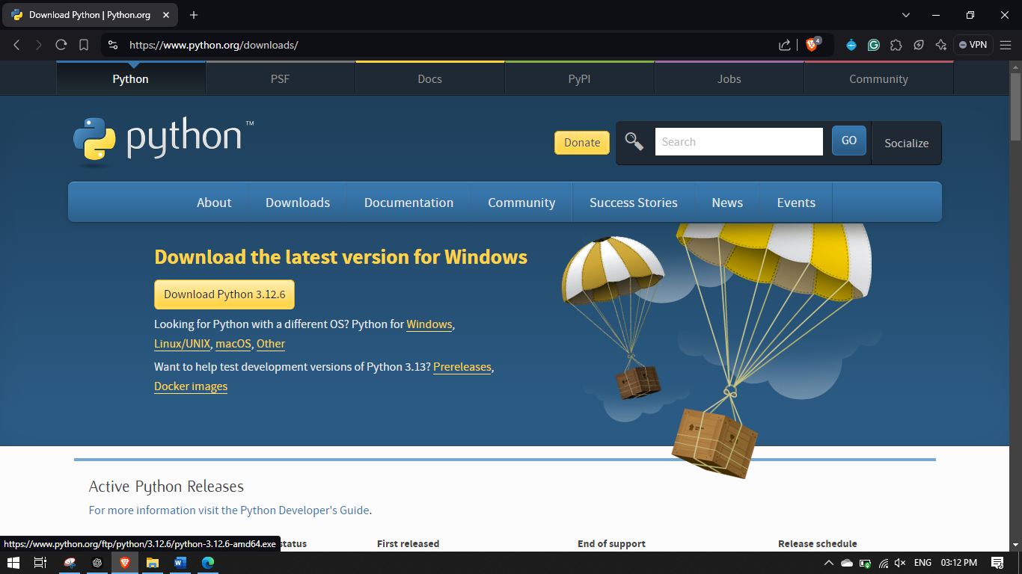

  - Install Required Libraries
Use pip to install the necessary libraries through requirements.txt
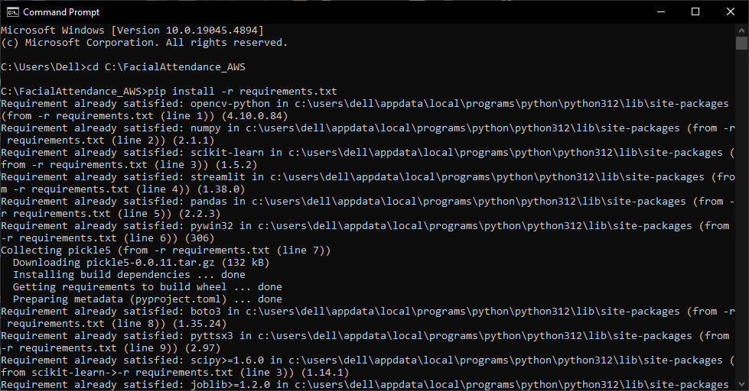

Step 2: AWS Configuration
2.1 Create an AWS Account
- Sign up for an AWS account at AWS.
- Follow the prompts to complete your registration.
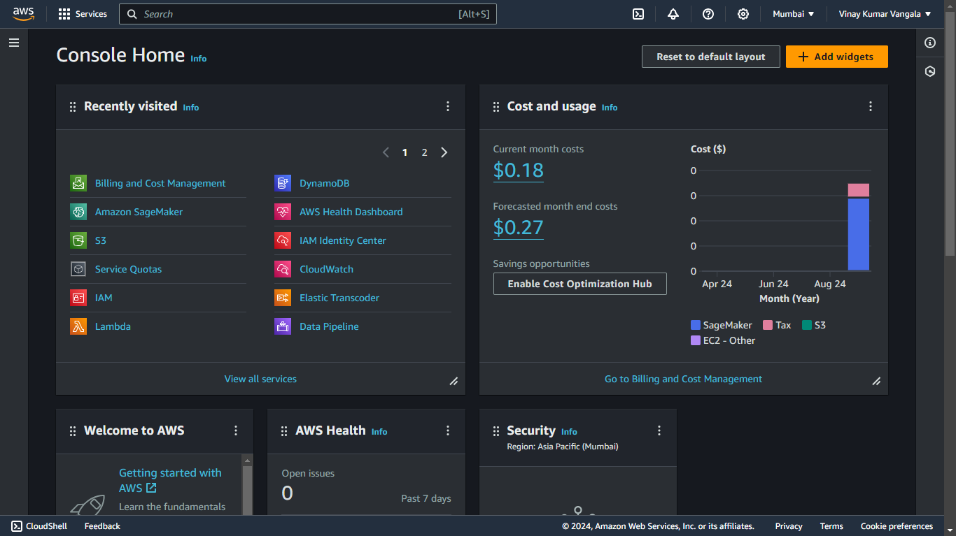
2.2 Create IAM User
- Navigate to the IAM dashboard in AWS.
- Click on Users and then Add user.
- Provide a username and select Programmatic access.
- Attach policies (e.g., AmazonS3FullAccess) to the user.
- Save the Access Key ID and Secret Access Key for later use.
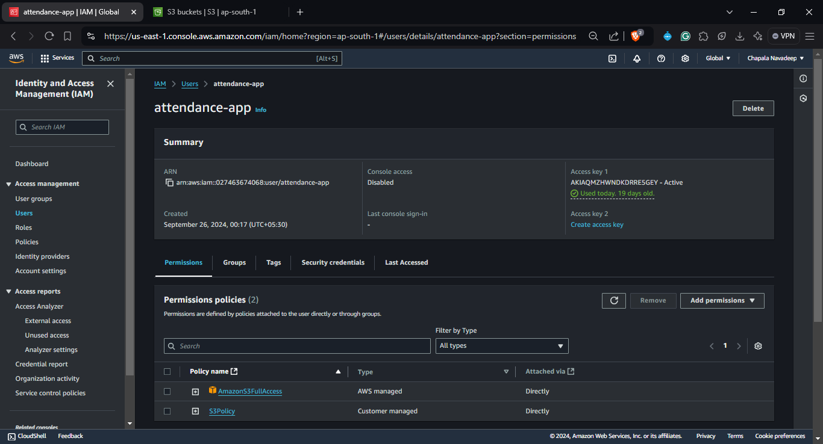
2.3 Create S3 Bucket
- Go to the S3 dashboard and click on Create bucket.
- Choose a globally unique name (e.g., facial-attendance-system).
- Configure options and create the bucket.
- Inside your S3 bucket, click on Create folder and name its Attendance/ (this is where your attendance CSVs will be stored).
- Navigate to your S3 bucket. Save the Bucket URL
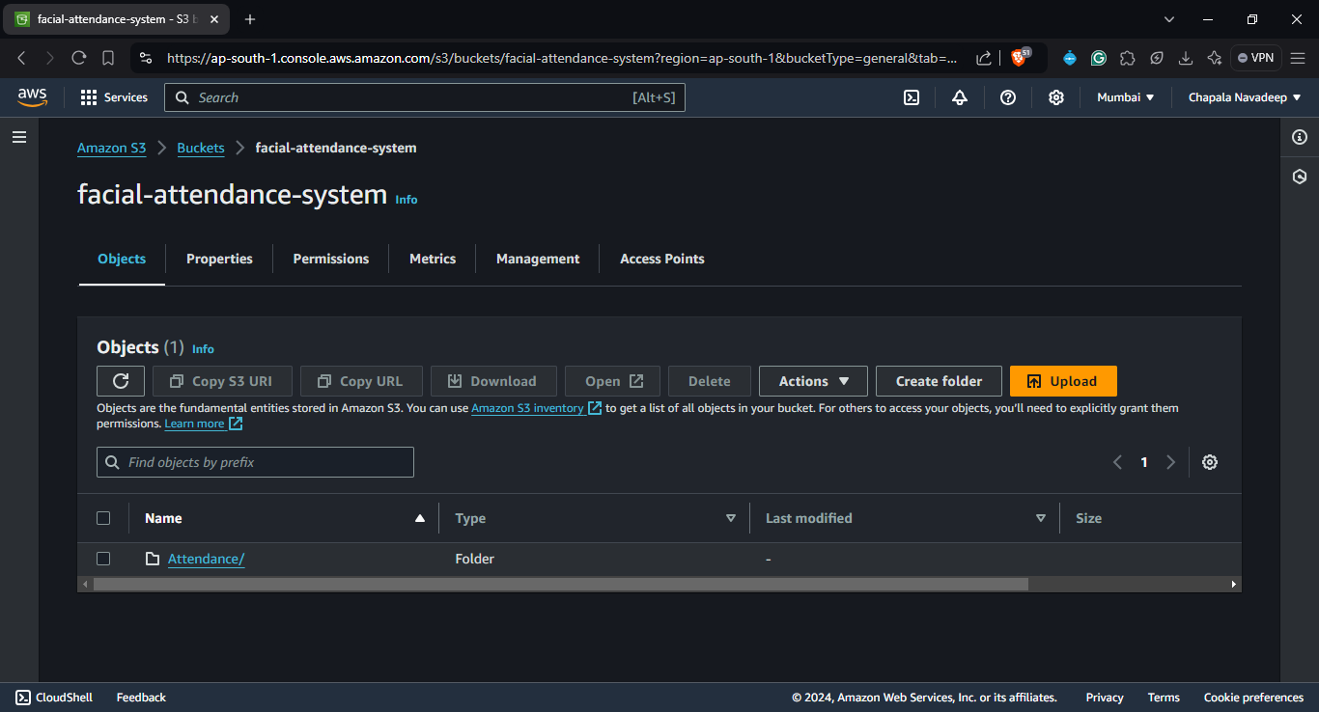
2.4 Set Bucket Policies
Configure the bucket policy to allow your IAM user to upload and retrieve files. Use the following sample policy:
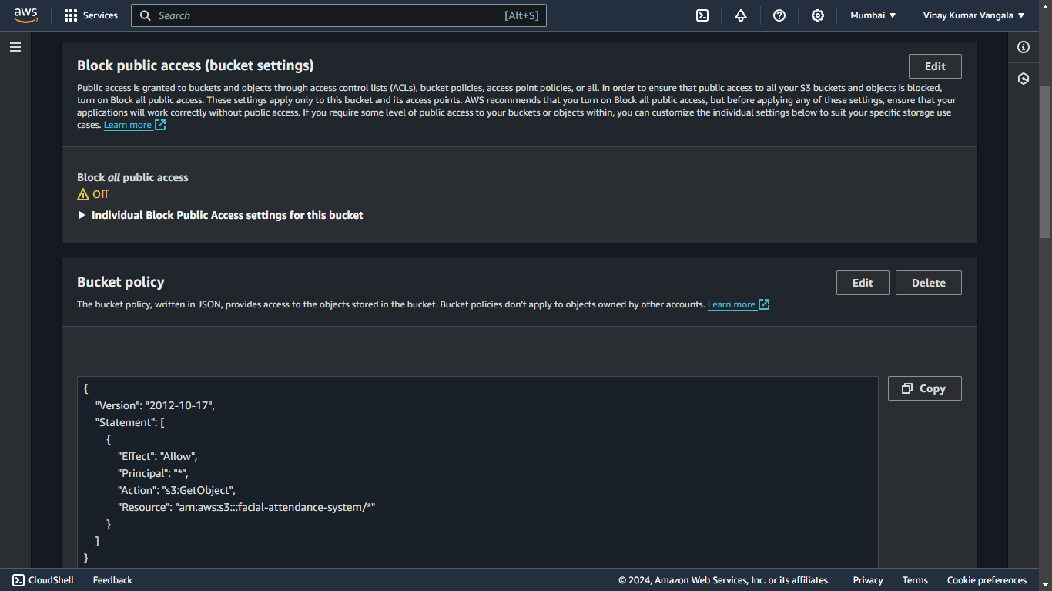

Step 3: Developing the Application
3.1 Create Main Application Files
Create three main Python files: add_faces.py, test.py, and app.py.

3.2 Clone the project repository
Create a project directory where you will store all your files.
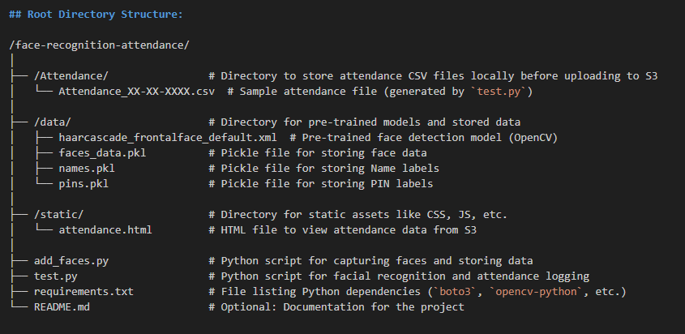

  - Implement Facial Recognition Logic
3.3.1 In add_faces.py, implement the functionality to capture and register faces along with their PINs.
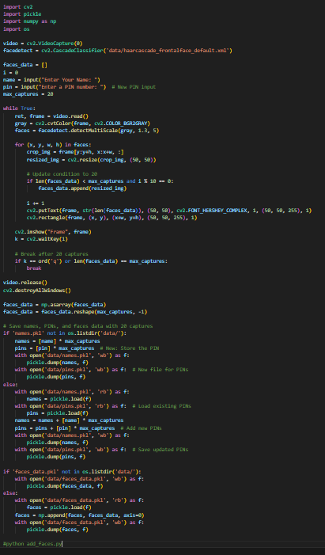

3.3.2 In test.py, integrate real-time face recognition and attendance marking using the PIN for verification.
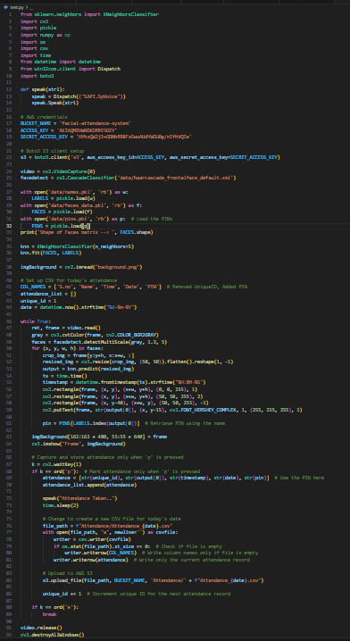
3.3.3 In attendance.html, The webpage used to display the attendance records. It fetches CSV data from AWS S3 and displays it in a table.

3.3.4 In app.py, create a Streamlit interface to display attendance data from the CSV file and allow users to search records.
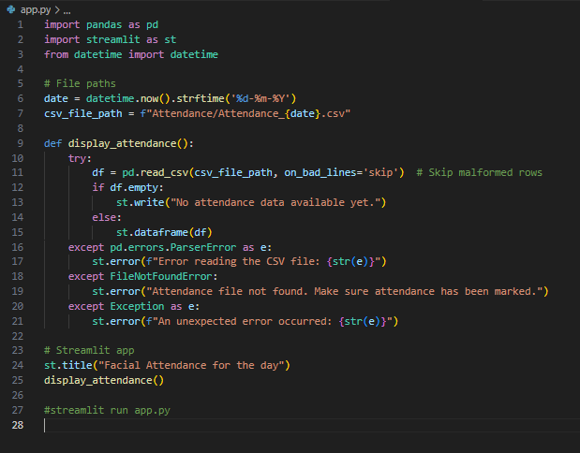

Step 4: Testing and Deployment
4.1 Test Your Application Locally
Run each file in your terminal to ensure that the functionalities are working as expected.
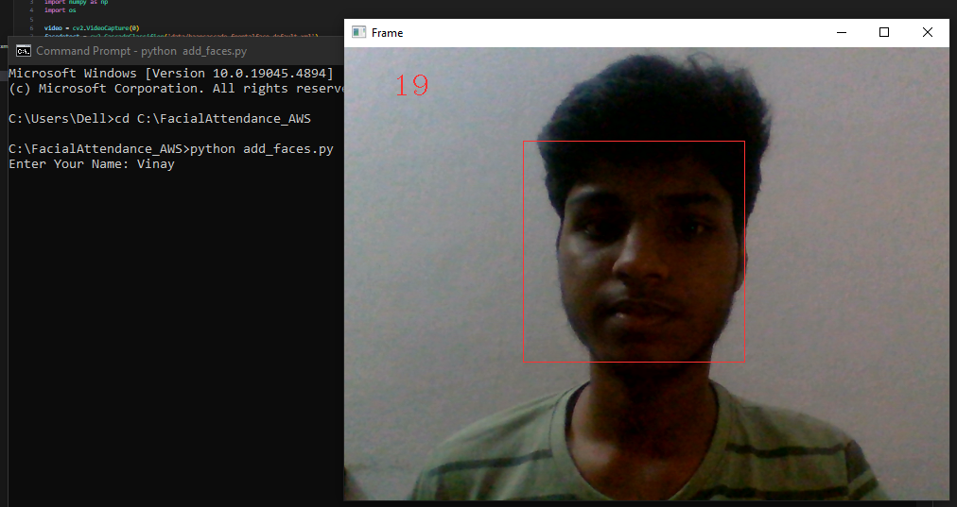
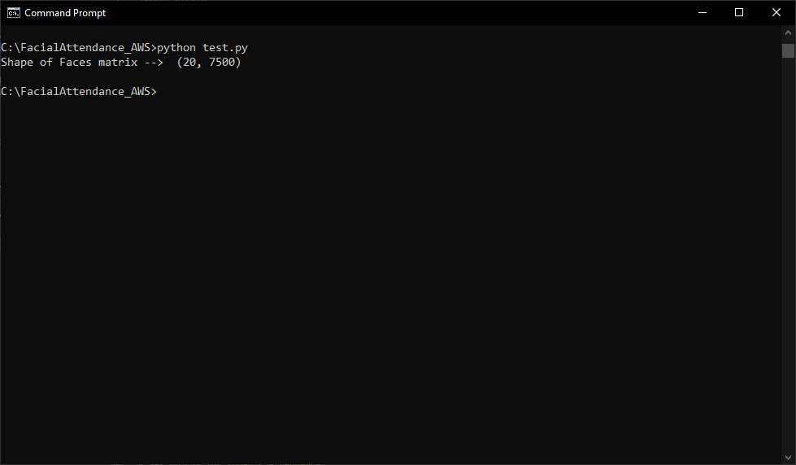
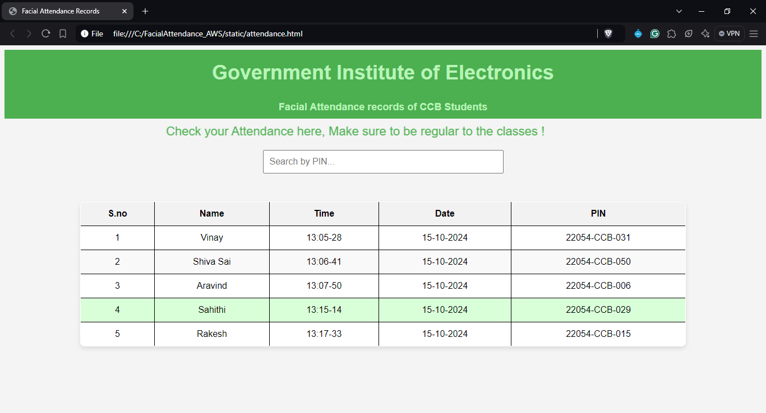
4.2 Run the Streamlit Application
Access the app via the provided local URL.
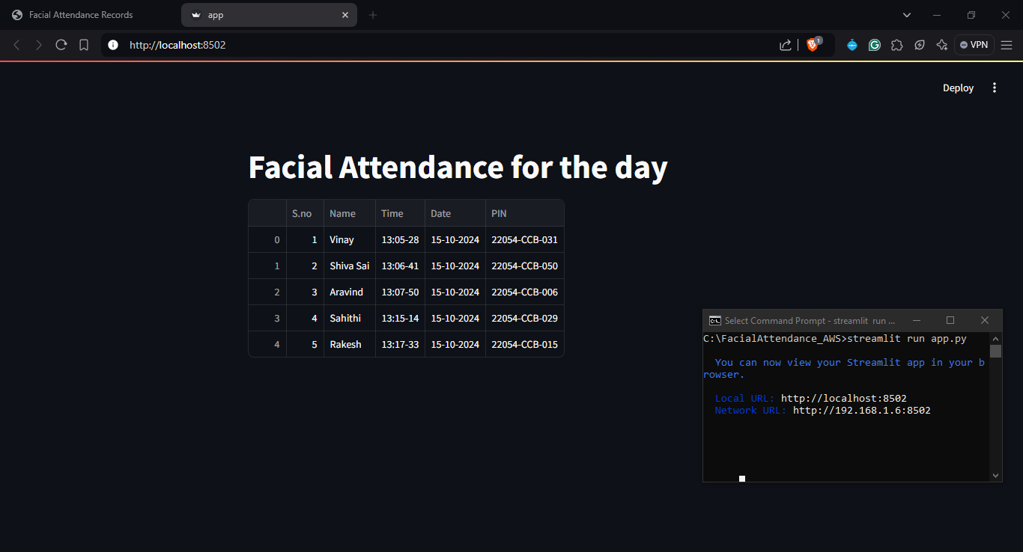

4.3 Upload Attendance Records to S3
Ensure your application successfully uploads the CSV file to your S3 bucket.
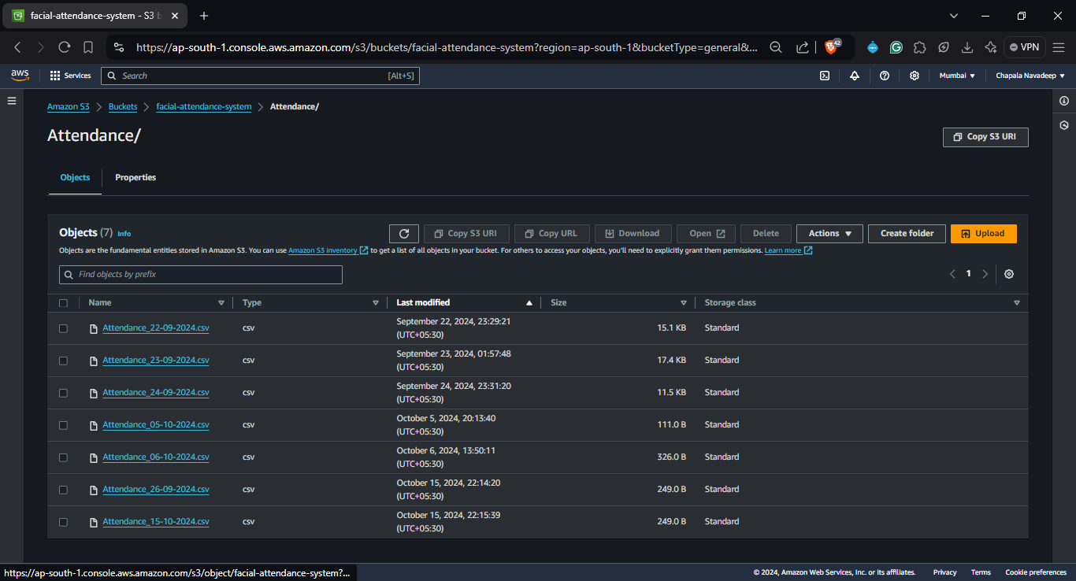

Step 5: Final Adjustments
- Review and Optimize Code
- Ensure all functionalities are working without any bugs and optimize your code for performance.

5.5 CONCLUSION

The Face Recognition Attendance System integrates modern technologies like face recognition and cloud storage to create a scalable, efficient attendance management solution. Leveraging Python and AWS, the system offers real-time attendance marking with automatic cloud backup. The web interface provides an easy way to visualize attendance records, ensuring accessibility and transparency for users. This project serves as an example of combining machine learning and cloud services to solve real-world problems effectively.

